SNAPSHOTS OF PROJECT:

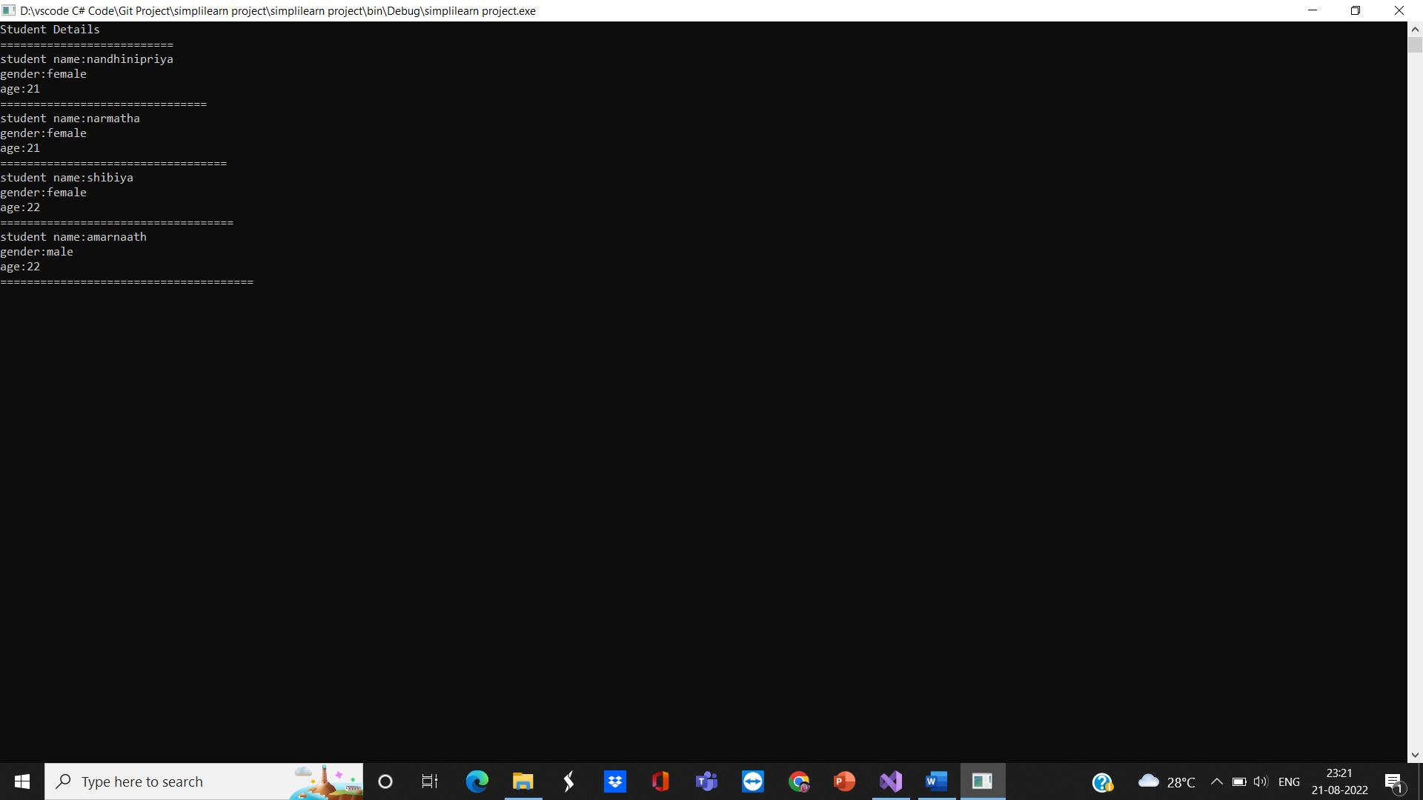

Notepad file:

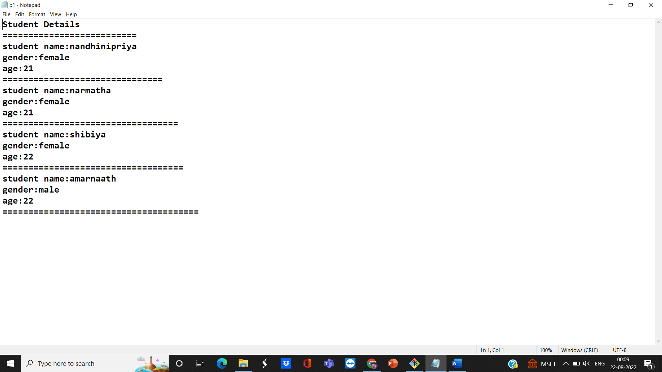

GITHUB LINK - <https://github.com/NandyPriya/Nandhu---.NET.git>